Access Statement
Kidspace Romford
The Brewery
Unit 1C-1D Waterloo Road
Romford
RM1 1AU
May 2026
1. Welcome
At Kidspace Romford, we are committed to creating a welcoming, inclusive and enjoyable environment for all children and adults. We believe every child should have the opportunity to play, explore and have fun. We recognize that our visitors may have a wide range of access needs, including mobility impairments, sensory sensitivities, neurodivergent conditions, learning disabilities and medical requirements, as well as the needs of parents, carers and extended family members.
Accessibility is not a one-size-fits-all approach, particularly within a busy children’s attraction. We aim to be open and honest about what we can provide and where limitations may exist. We are continually reviewing our facilities, services and staff training to improve accessibility and remove barriers wherever reasonably possible. If you have specific access requirements, we encourage you to contact us in advance so we can discuss how best to support your visit.
2. Pre-Arrival Information
By Bus
Romford bus interchange is located on site at The Brewery, with multiple local and regional bus routes serving the area.
By Train
Romford railway station is located directly next to The Brewery retail and leisure complex, providing easy access to Kidspace Romford.
By Car
Romford is 12 miles east of the City of London and 5 miles from Junctions 28 and 29 of the M25 motorway.
Kidspace Romford is in The Brewery - an integrated retail and leisure complex adjacent to Romford Town Centre. The Brewery has 1,750 parking spaces with ground level and multi-storey parking available. Parking must be paid for online or at the pay station before exit.
Contacting Us in Advance
www.kidspaceadventures.comWebsite: www.kidspaceadventures.com
Phone: 01708 598930 Email: romfordinfo@kidspaceadventures.com
Live chat is available via our website.
3. Booking & Tickets
All visits must be booked online in advance. If you require assistance with booking, please contact our team and we will be happy to help.
Access Card & Digital Access Pass
Kidspace Romford supports the nationally recognized Access Card Scheme, operated by Nimbus Disability. The Access Card allows visitors to share their access requirements discreetly and consistently across participating venues, reducing the need to repeatedly explain personal circumstances. If you do not hold an Access Card, you may apply for Kidspace Digital Access Pass, administered by Nimbus Disability. This free, venue-specific registration allows us to understand your access needs in advance and offer appropriate support. It is valid for use at Kidspace only. More information can be found on our accessibility page.
Essential Companion Tickets
Visitors displaying a +1 or +2 symbol on their Access Card or Kidspace Digital Access Pass are entitled to book one or two Essential Companion tickets free of charge.
The Access Card holder and Essential Companion(s) must enter together. Photo identification linked to the card/pass will be checked at Reception. Essential Companion tickets must be booked online. Our booking system links directly with the Nimbus portal to verify eligibility in advance.
Role of an Essential Companion
An Essential Companion must be able to provide the necessary support to the visitor throughout their time at Kidspace, including assistance during emergency evacuation if required.
While our team will always make reasonable adjustments where possible, staff are unable to provide one-to-one supervision or personal care. Where misuse of the Essential Companion scheme is identified, Kidspace reserves the right to withdraw from access to the scheme for future visits.
Young Carers
For safeguarding reasons, all children under 18 must be supervised by an adult while visiting Kidspace. One adult may supervise up to four children. We recognize and value the role of young carers. However, we can only accept them under the Essential Companion scheme where there is no risk of them being left solely responsible for supervision.
4. Car Parking & Arrival
Accessible parking bays are available within both ground level and multi-storey car parks. The route from parking to the entrance is smooth, level and clearly signed. Visitors displaying the relevant Access Card symbol may request alternative queuing arrangements or rest seating during entry. Seating is available throughout the attraction, and staff can advise on the shortest walking routes if required.

Entrance
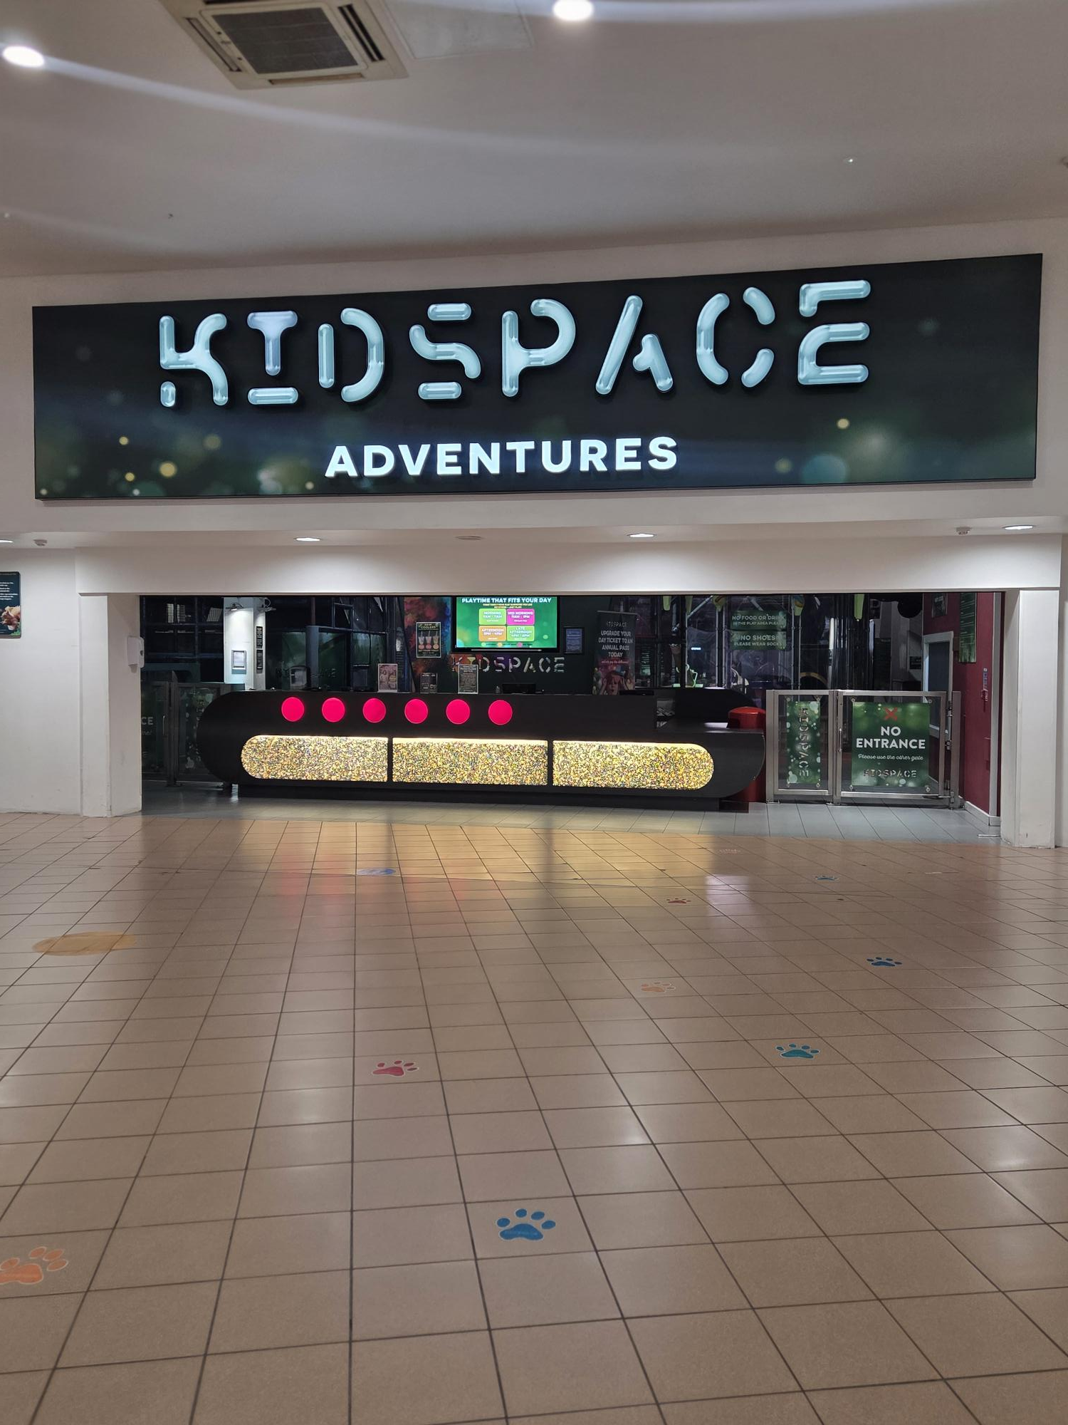

5. Main Entrance & Reception
Step-free access is available at the main entrance. Reception is located on the same internal level as the attraction, with no additional levels inside the venue for visitors to access. The attraction is largely open-plan, with wide walkways and minimal internal doors other than toilets and fire exits. Alternative queuing arrangements are not always available; however, staff will assist where reasonably possible.

- Main entrance gate

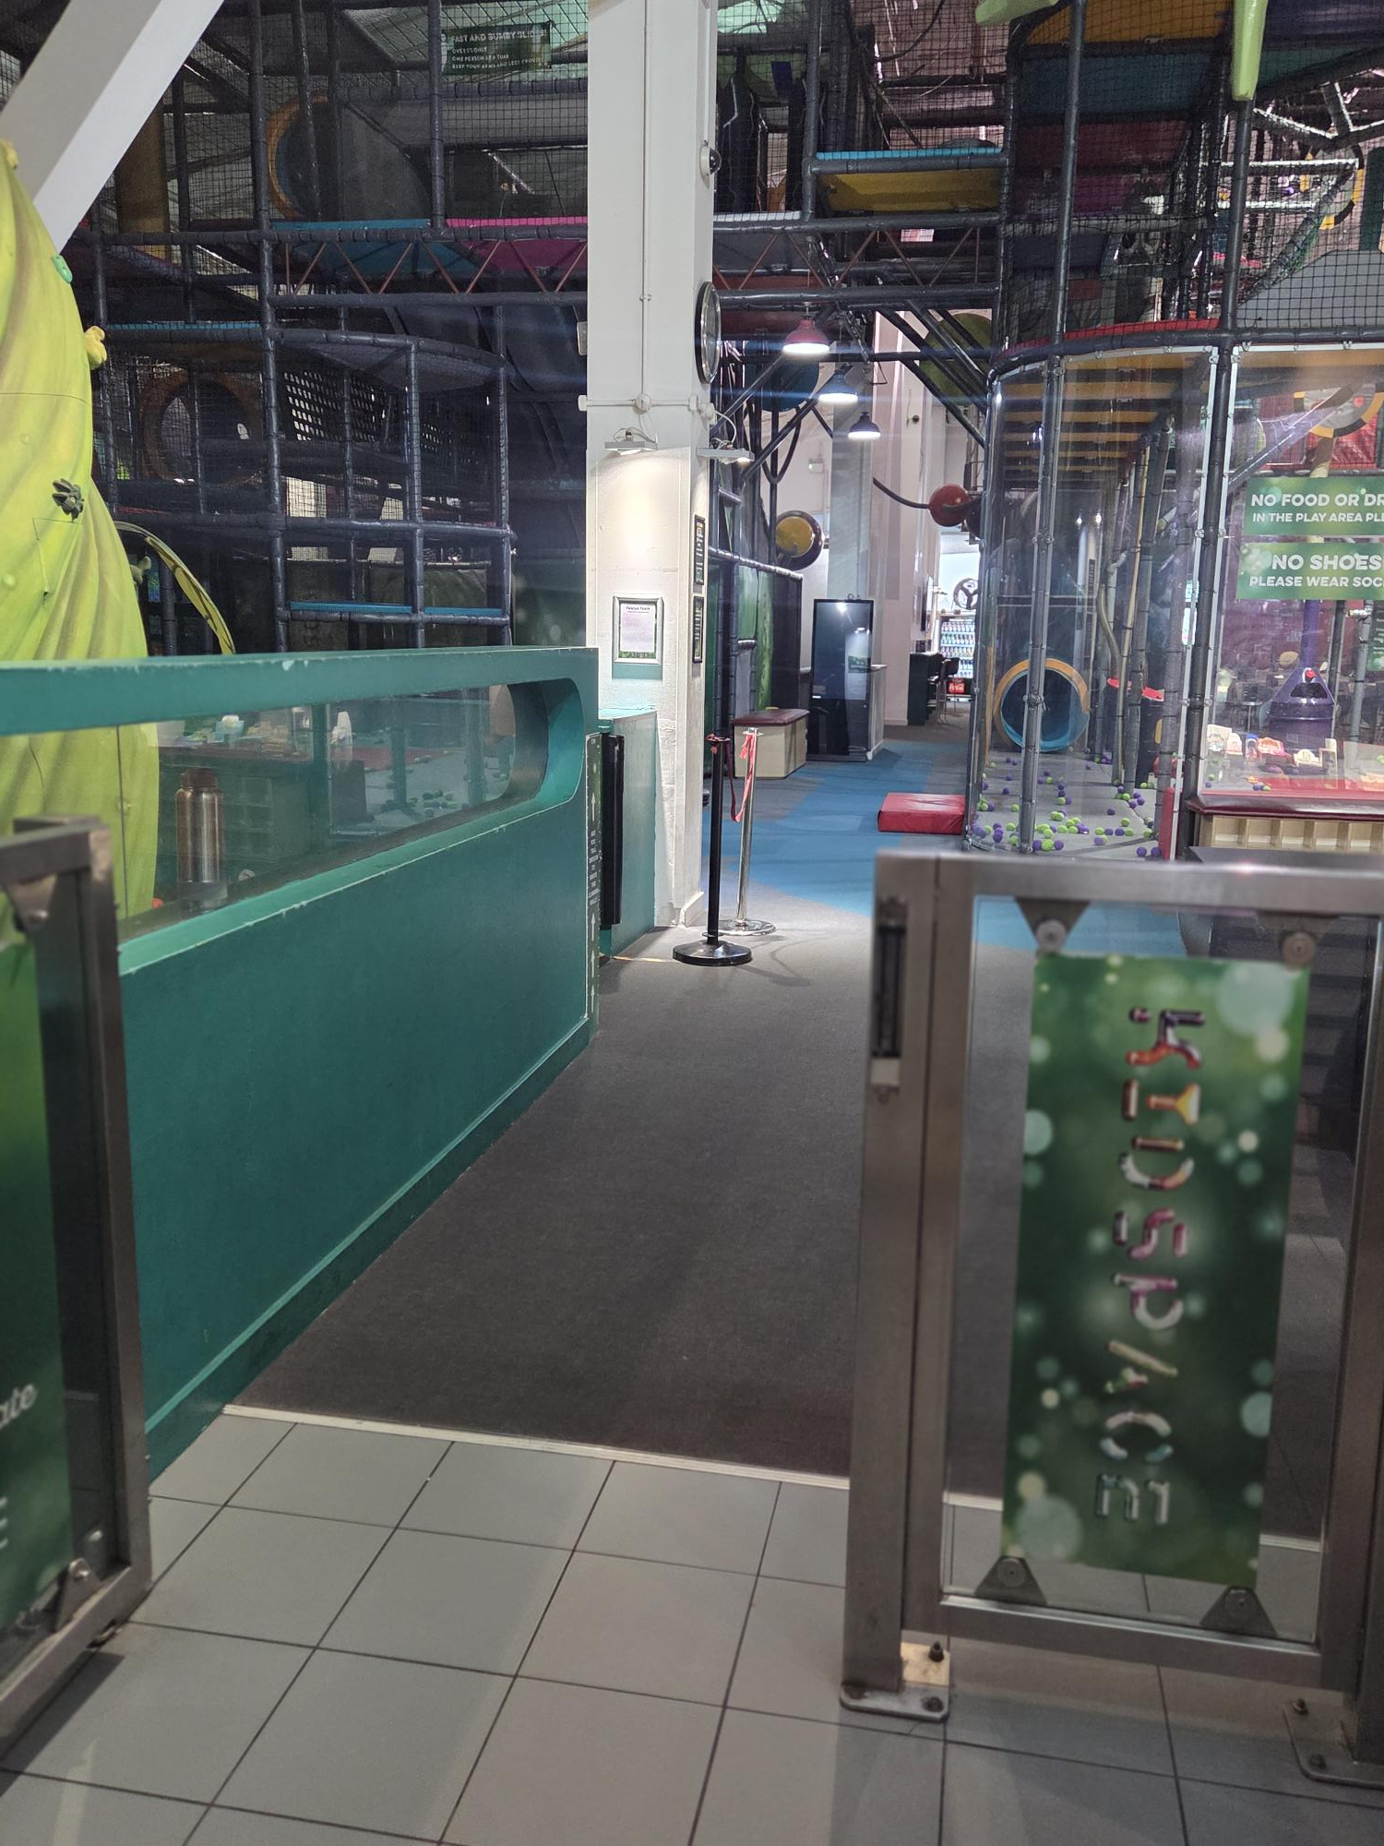

6. Mobility & Level Access
● Step-free routes are available throughout the venue.
● Suitable for wheelchairs, mobility aids and mobility scooters.
● Seating is spaced throughout the attraction.
● Staff are happy to advise on accessible routes and shorter walking distances.

Internal walkway
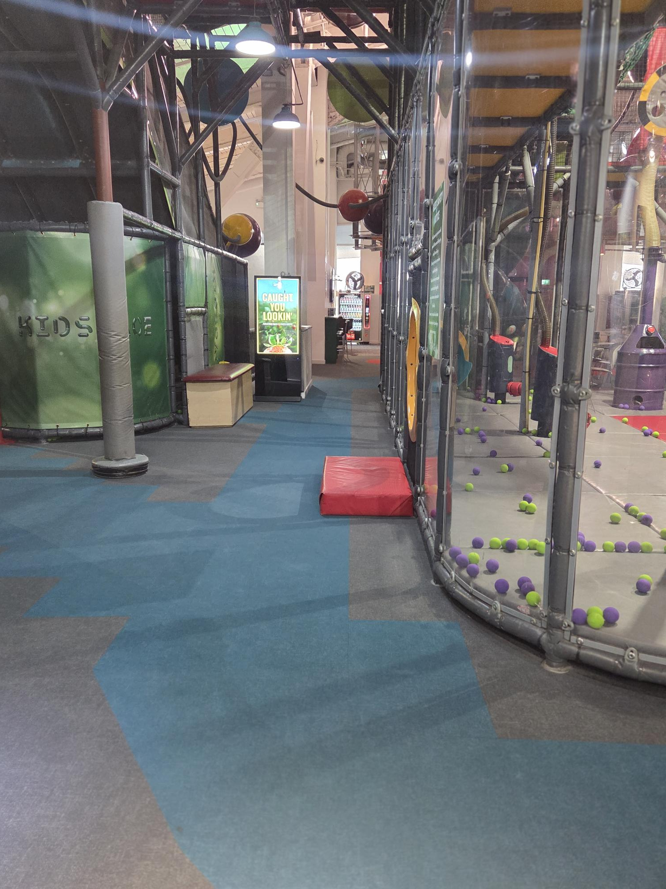

7. Toilets & Changing Facilities
● Accessible toilet facilities with grab rails and emergency alarm.
● Baby changing facilities available.
● Visitors displaying the relevant Access Card symbol may request urgent access to toilet facilities where needed.
Accessible toilet

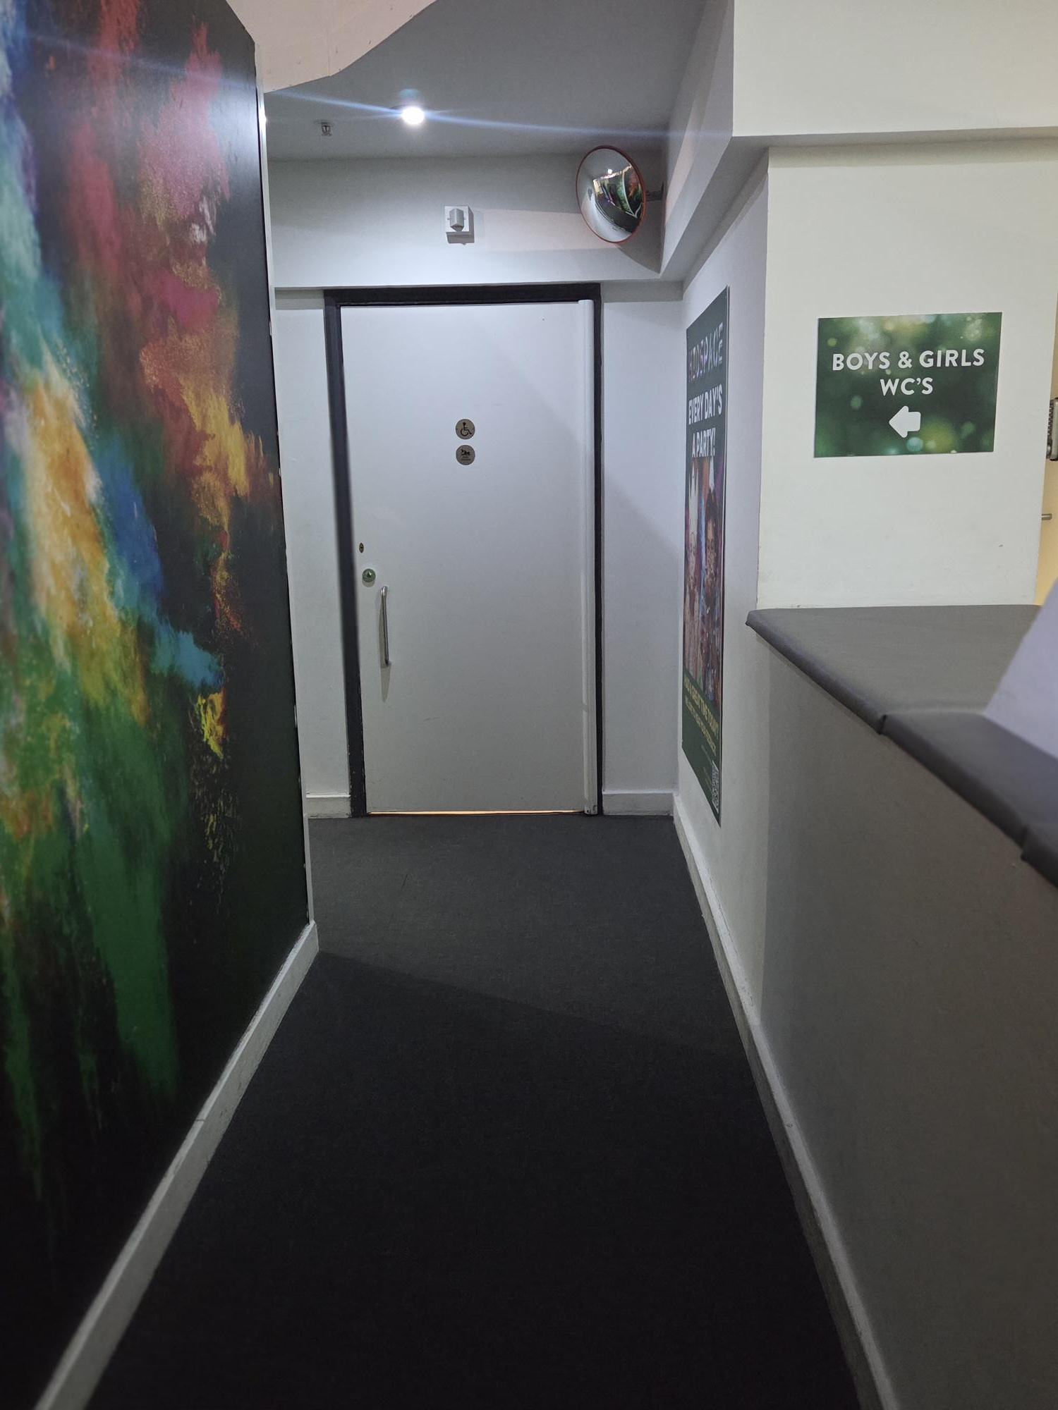
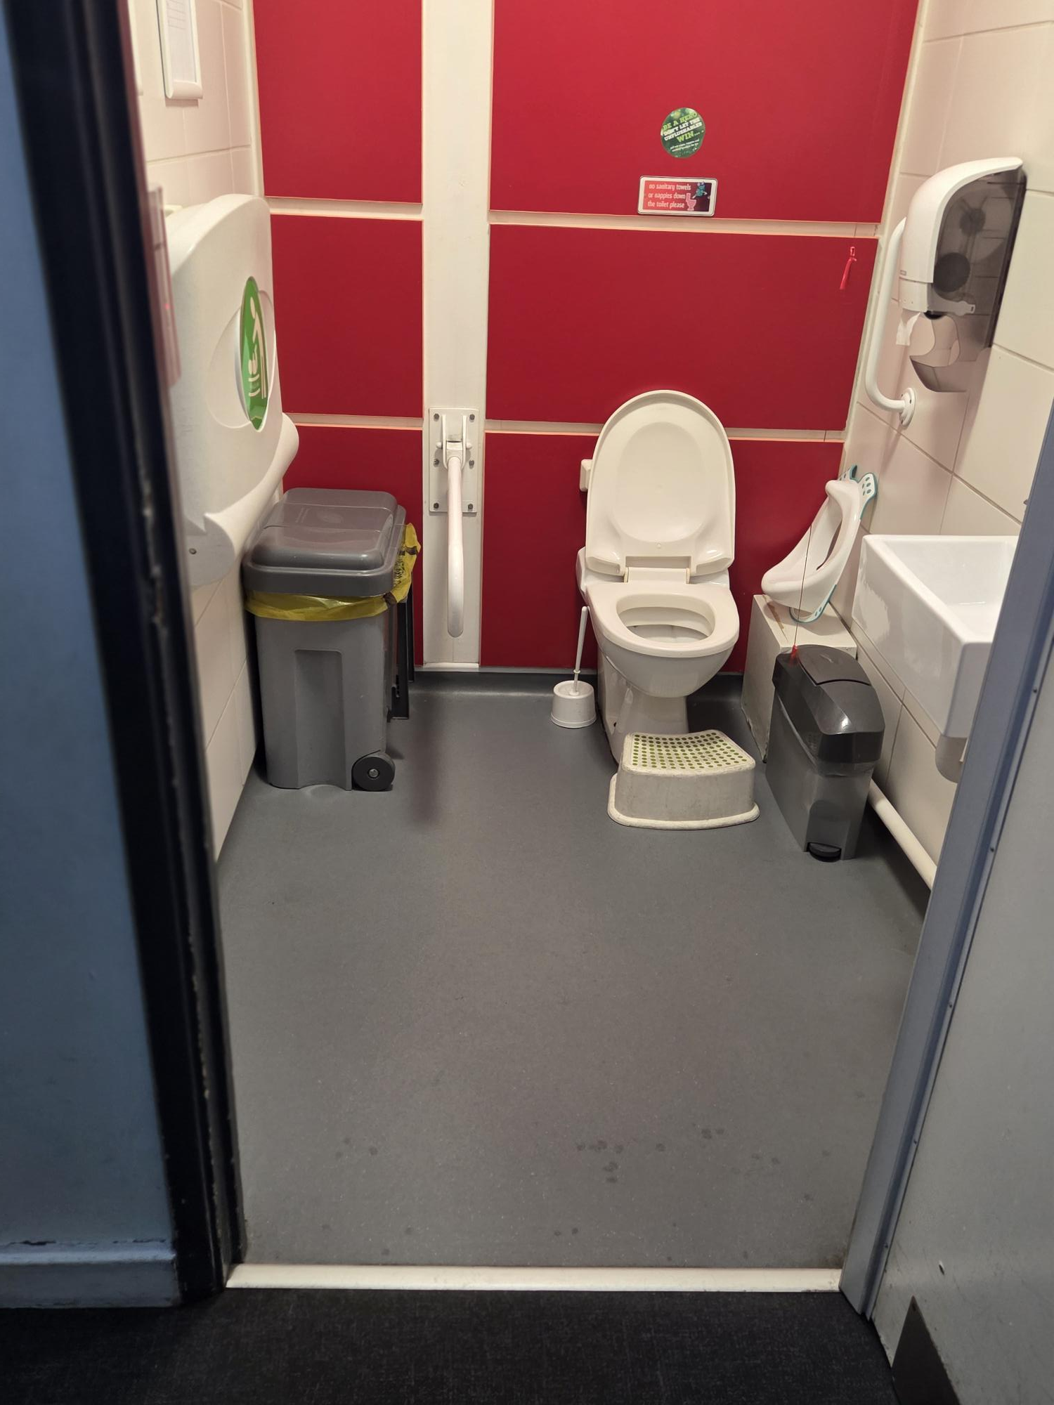

8. Café & Food Services
● Step-free access to café area.
● Table layouts allow for wheelchair access between seating areas.
● Staff assistance is available where required.
● Allergen and dietary information is available on request.

9. Indoor Play Areas
Our play areas are designed for active exploration and imaginative play. Accessible viewing and seating areas are available throughout the venue to allow rest breaks where needed. Due to the nature of soft play equipment, some structures may not be suitable for certain mobility needs. Staff are happy to discuss individual requirements in advance.

10. Sensory Considerations
Kidspace is a lively and stimulating environment. Background music is played at low volume, and there is natural noise from children playing, including birthday parties and group visits. The open-plan layout means sound can travel across different areas. Visitors with sensory sensitivities may find peak times busy or noisy. We recommend visiting during quieter periods, such as weekday mornings during term time. Families are welcome to bring ear defenders or other supportive equipment.

11. Assistance Dogs
Assistance Dogs are welcome throughout the attraction when accompanying their owner. Assistance Dogs must be fully trained and accustomed to busy, indoor environments. For safety and hygiene reasons, we are unable to permit other dogs or pets. Emotional Support Animals are not currently permitted. If you require additional support, please contact us in advance to discuss reasonable adjustments.

12. Communication Support
Further communication support is available. Please request verbal explanations or alternative formats, such as large print where available. We welcome open conversations about individual access needs — there is no requirement to disclose a diagnosis. Simply let our team know how we can best support you.

13. Staff Training
Our team receives training to promote inclusive, respectful and supportive service. We encourage staff to listen, adapt and make reasonable adjustments wherever possible.

14. Emergency Evacuation
Evacuation procedures are in place to support all visitors, including those with additional needs. In the event of an emergency, staff will provide assistance wherever possible. Alternative procedures will be followed where required.

15. Temporary Disruptions
If any facilities or accessibility features are temporarily unavailable, we will communicate this via our website as soon as reasonably possible. Clear signage and alternative arrangements will be provided where available.

16. Feedback
Accessibility is an ongoing process. We regularly review our facilities, policies and training and welcome feedback from visitors to help us continue improving. If you would like to provide feedback or discuss your visit, please contact us.

